**LAPORAN PRAKTIKUM**

**MODUL 1: REVIEW MOBILE DASAR**



**Oleh:**

Fany Ervansyah

1641720080

**PRUGRAM STUDI D4 TEKNIK INFORMATIKA**

**JURUSAN TEKNOLOGI INFORMASI**

**POLITEKNIK NEGERI MALANG**

**2019**

# DAFTAR ISI

[DAFTAR ISI 2](#_Toc8476)

[DAFTAR GAMBAR 3](#_Toc9398)

[DAFTAR SOURCECODE 4](#_Toc5811)

[1. LATAR BELAKANG 5](#_Toc31950)

[2. TUJUAN 5](#_Toc16118)

[3. PERANCANGAN 6](#_Toc24836)

[4. IMPLEMENTASI 7](#_Toc12153)

[4.1. IMPLEMENTASI SOURCECODE 7](#_Toc7087)

[4.2. IMPLEMENTASI TAMPILAN 12](#_Toc12288)

[5. DAFTAR PUSTAKA 13](#_Toc2339)

# DAFTAR GAMBAR

[Gambar 3-I Mockup Main Activity 1 6](#_Toc28814)

[Gambar 3-II Mockup Main Activity 2 6](#_Toc11897)

[Gambar 3-III Mockup Main Activity 3 7](#_Toc14902)

*[Gambar 4-I Activity 1](#_Toc5301)* [12](#_Toc5301)

*[Gambar 4-II Activity 2](#_Toc24965)* [13](#_Toc24965)

*[Gambar 4-III Activity 3](#_Toc22881)* [13](#_Toc22881)

# DAFTAR SOURCECODE

[Sorcecode 4.1 Sourcecode MainActivity.java 8](#_Toc1093)

[Sorcecode 4.2 Sourcecode MainActivity.xml 8](#_Toc19902)

[Sorcecode 4.3 Sourcecode Main2Activity.java 9](#_Toc8584)

[Sorcecode 4.4 Sourcecode Main2Activity.xml 10](#_Toc4661)

[Sorcecode 4.5 Sourcecode Main3Activity.java 11](#_Toc17921)

[Sorcecode 4.6 Sourcecode Main3Activity.xml 12](#_Toc31572)

# LATAR BELAKANG

Dalam pemrograman Android di Android Studio, **Layout** berguna untuk mengatur penempatan komponen sehingga, tampilan aplikasi akan tampak rapi dan teratur. **Recycle View** berguna untuk menampilkan data dalam jumlah besar pada komponen yang digunakan berulang-ulang. **SharedPreference** adalah penyimpanan yang hanya menyimpan data berukuran kecil dan sederhana. **Intent** adalah objek pada pemrograman Android yang digunakan untuk berpindah halaman atau berkomunikasi dengan halaman lain. **SQLite** adalah sebuah database relasional yang berbentuk sebuah file (Bukan Client-Server). **Retrofit** adalah client HTTP type-safe untuk Android dan Java yang memudahkan untuk terhubung ke layanan REST pada suatu web.

# TUJUAN

1. Mengingat kembali materi - materi yang telah diajarkan dalam pengembangan Aplikasi berbasis Mobile.
2. Mempersiapkan diri dalam dunia kerja, khususnya pada industri pengembangan aplikasi berbasis mobile.

# PERANCANGAN

Gambar 3-I Mockup Main Activity 1

Gambar 3-II Mockup Main Activity 2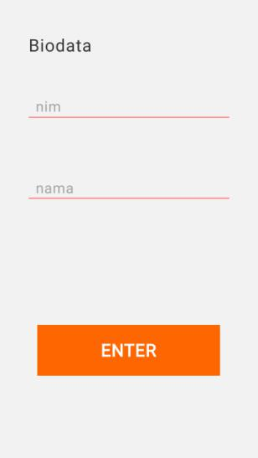

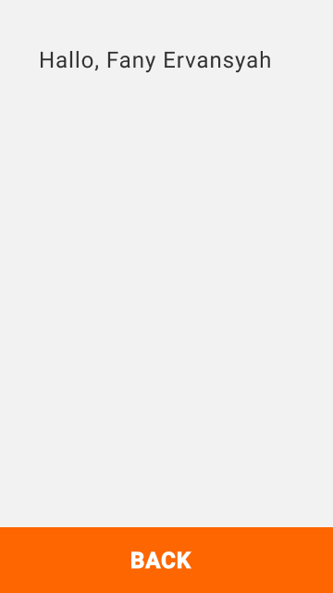Gambar 3-III Mockup Main Activity 3

# IMPLEMENTASI

## IMPLEMENTASI SOURCECODE

|  |
| --- |
| package com.example.app1;  import android.content.Intent;  import android.os.Bundle;  import com.google.android.material.floatingactionbutton.FloatingActionButton;  import com.google.android.material.snackbar.Snackbar;  import androidx.appcompat.app.AppCompatActivity;  import androidx.appcompat.widget.Toolbar;  import android.view.View;  import android.view.Menu;  import android.view.MenuItem;  import android.widget.Button;  public class MainActivity extends AppCompatActivity {  @Override  protected void onCreate(Bundle savedInstanceState) {  super.onCreate(savedInstanceState);  setContentView(R.layout.activity\_main);  Button btnGetStarted = findViewById(R.id.buttonGetStarted);  btnGetStarted.setOnClickListener(new View.OnClickListener() {  @Override  public void onClick(View view) {  Intent i = new Intent(MainActivity.this, Main2Activity.class);  startActivity(i);  }  });  }  } |

Sorcecode 4.1 Sourcecode MainActivity.java

<?xml version="1.0" encoding="utf-8"?>

<LinearLayout xmlns:android="http://schemas.android.com/apk/res/android"

xmlns:tools="http://schemas.android.com/tools"

android:layout\_width="match\_parent"

android:layout\_height="match\_parent"

app:layout\_behavior="@string/appbar\_scrolling\_view\_behavior"

android:orientation="vertical"

android:background="#04f"

tools:context=".MainActivity"

tools:showIn="@layout/activity\_main">

<ImageView

android:layout\_width="200dp"

android:layout\_height="200dp"

android:src="@drawable/polinemalogo"

android:layout\_gravity="center\_horizontal"

android:layout\_marginTop="170dp"/>

<Button

android:id="@+id/buttonGetStarted"

android:layout\_width="300dp"

android:layout\_height="80dp"

android:layout\_marginTop="100dp"

android:layout\_gravity="center\_horizontal"

android:text="GET STARTED"

android:textSize="25dp"

android:textColor="#ffffff"

android:background="#ff8100"/>

</LinearLayout>

Sorcecode 4.2 Sourcecode MainActivity.xml

package com.example.app1;

import androidx.appcompat.app.AppCompatActivity;

import android.content.Intent;

import android.os.Bundle;

import android.view.View;

import android.widget.Button;

import android.widget.TextView;

public class Main2Activity extends AppCompatActivity {

@Override

protected void onCreate(Bundle savedInstanceState) {

super.onCreate(savedInstanceState);

setContentView(R.layout.activity\_main2);

Button btnEnter = findViewById(R.id.buttonEnter);

final TextView tvUsername = findViewById(R.id.nama);

btnEnter.setOnClickListener(new View.OnClickListener() {

@Override

public void onClick(View view) {

Intent i = new Intent(Main2Activity.this, Main3Activity.class);

i.putExtra("username", tvUsername.getText().toString());

startActivity(i);

}

});

}

}

Sorcecode 4.3 Sourcecode Main2Activity.java

<?xml version="1.0" encoding="utf-8"?>

<RelativeLayout xmlns:android="http://schemas.android.com/apk/res/android"

xmlns:tools="http://schemas.android.com/tools"

android:layout\_width="match\_parent"

android:layout\_height="match\_parent"

tools:context=".Main2Activity">

<TextView

android:id="@+id/biodata"

android:layout\_width="wrap\_content"

android:layout\_height="wrap\_content"

android:text="Biodata"

android:textSize="40dp"

android:layout\_marginTop="30dp"

android:layout\_marginLeft="30dp"/>

<EditText

android:id="@+id/nim"

android:layout\_width="match\_parent"

android:layout\_height="wrap\_content"

android:layout\_below="@+id/biodata"

android:hint="nim"

android:layout\_marginTop="40dp"

android:layout\_marginLeft="30dp"

android:layout\_marginRight="30dp"/>

<EditText

android:id="@+id/nama"

android:layout\_width="match\_parent"

android:layout\_height="wrap\_content"

android:layout\_below="@+id/nim"

android:hint="nama"

android:layout\_marginTop="40dp"

android:layout\_marginLeft="30dp"

android:layout\_marginRight="30dp"/>

<Button

android:id="@+id/buttonEnter"

android:layout\_width="match\_parent"

android:layout\_height="wrap\_content"

android:layout\_below="@+id/nama"

android:text="ENTER"

android:textSize="30dp"

android:textColor="#fff"

android:background="@color/colorOrange"

android:layout\_marginTop="70dp"

android:layout\_marginLeft="30dp"

android:layout\_marginRight="30dp"/>

</RelativeLayout>

Sorcecode 4.4 Sourcecode Main2Activity.xml

package com.example.app1;

import androidx.appcompat.app.AppCompatActivity;

import android.content.Intent;

import android.os.Bundle;

import android.view.View;

import android.widget.Button;

import android.widget.TextView;

public class Main3Activity extends AppCompatActivity {

@Override

protected void onCreate(Bundle savedInstanceState) {

super.onCreate(savedInstanceState);

setContentView(R.layout.activity\_main3);

Intent i = getIntent();

TextView tvUsername = findViewById(R.id.textViewUsername);

Button btnBack = findViewById(R.id.back);

String text = "Hallo, "+i.getStringExtra("username");

tvUsername.setText(text);

btnBack.setOnClickListener(new View.OnClickListener() {

@Override

public void onClick(View view) {

finish();

}

});

}

}

Sorcecode 4.5 Sourcecode Main3Activity.java

<?xml version="1.0" encoding="utf-8"?>

<androidx.constraintlayout.widget.ConstraintLayout xmlns:android="http://schemas.android.com/apk/res/android"

xmlns:app="http://schemas.android.com/apk/res-auto"

xmlns:tools="http://schemas.android.com/tools"

android:layout\_width="match\_parent"

android:layout\_height="match\_parent"

tools:context=".Main3Activity">

<TextView

android:id="@+id/textViewUsername"

android:layout\_width="wrap\_content"

android:layout\_height="wrap\_content"

android:text="Halo, Username"

android:textColor="#555"

android:textSize="40dp"

app:layout\_constraintStart\_toStartOf="parent"

app:layout\_constraintTop\_toTopOf="parent"

android:layout\_marginTop="50dp"

android:layout\_marginLeft="20dp"

android:maxWidth="300dp"/>

<Button

android:id="@+id/back"

android:layout\_width="match\_parent"

android:layout\_height="wrap\_content"

app:layout\_constraintBottom\_toBottomOf="parent"

app:layout\_constraintEnd\_toEndOf="parent"

android:text="BACK"

android:textColor="#fff"

android:textSize="40dp"

android:background="@color/colorOrange"

/>

</androidx.constraintlayout.widget.ConstraintLayout>

Sorcecode 4.6 Sourcecode Main3Activity.xml

## IMPLEMENTASI TAMPILAN

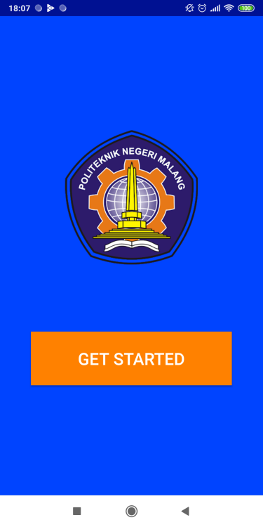

***Gambar 4-I Activity 1***

***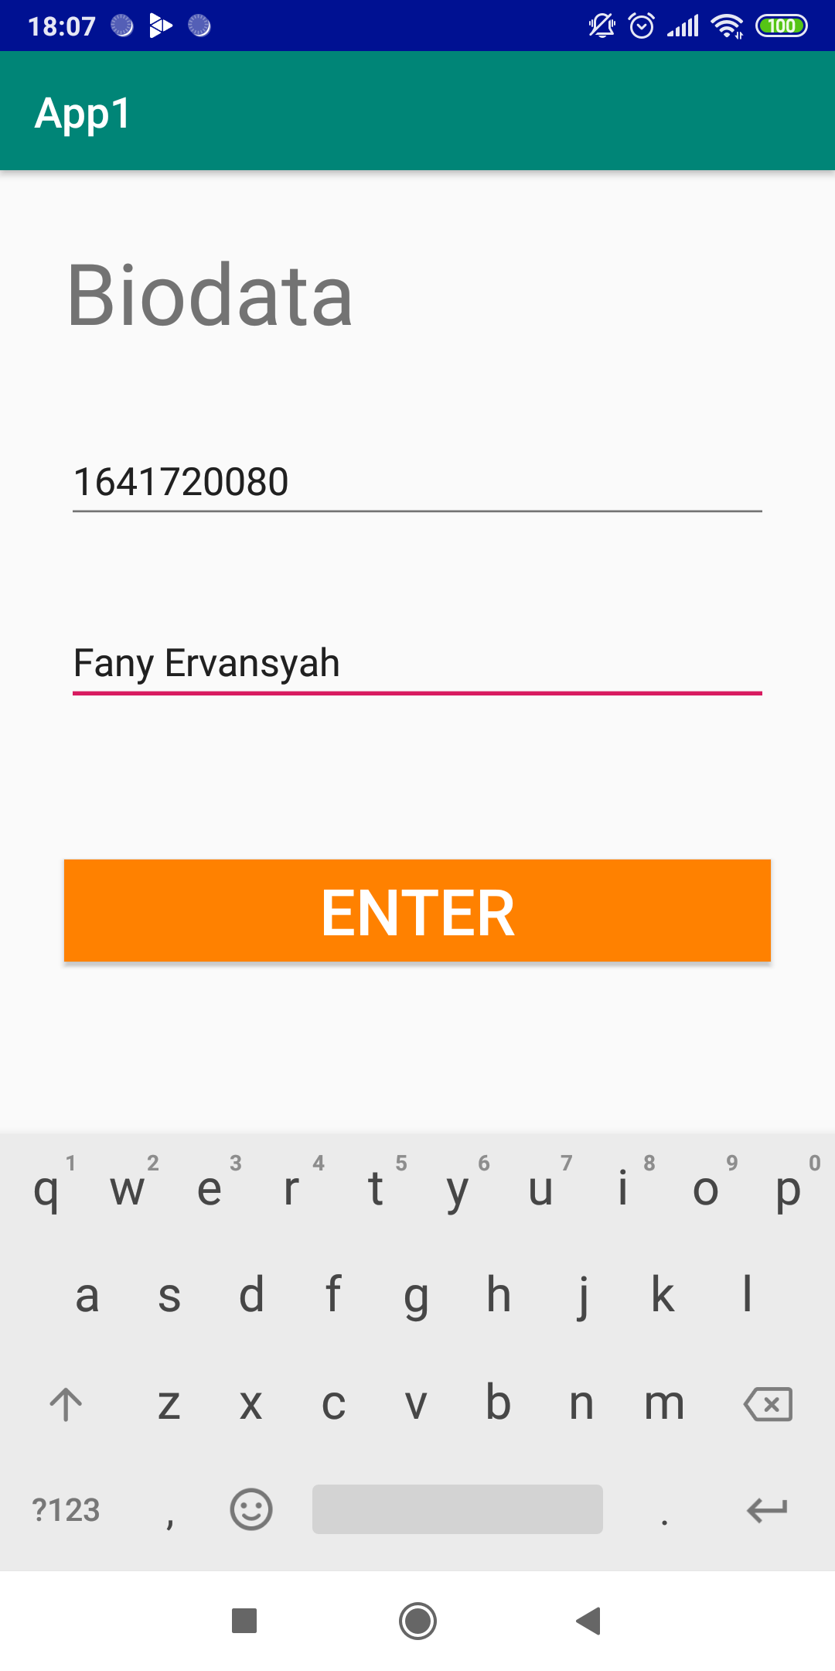***

***Gambar 4-II Activity 2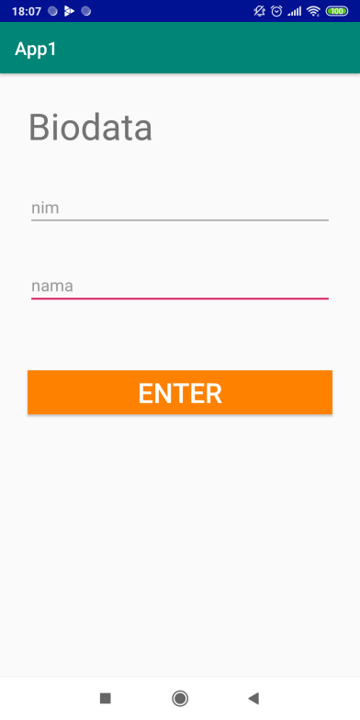***

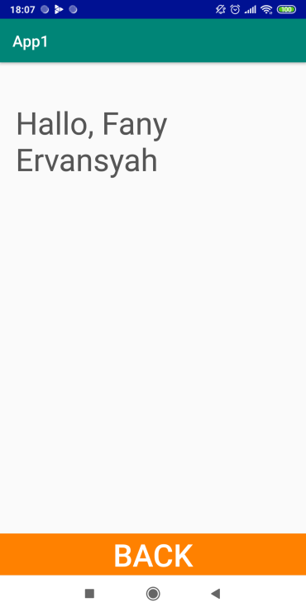

***Gambar 4-III Activity 3***

# DAFTAR PUSTAKA

1. <https://www.codepolitan.com/mempelajari-layout-pada-android-studio>
2. [https://google-developer-training.github.io/android-developer-fundamentals-course-concepts/idn/Unit%202/44\_c\_recyclerview.html](https://google-developer-training.github.io/android-developer-fundamentals-course-concepts/idn/Unit 2/44_c_recyclerview.html)
3. <https://medium.com/dot-lab/tutorial-penggunaan-shared-preferences-pada-android-eddc300d7509>
4. <https://www.codepolitan.com/belajar-menggunakan-intent-sebuah-jembatan-interaksi-antar-komponen-599a5576271ef>
5. <https://www.codepolitan.com/5-keunggulan-sqlite>
6. <https://code.tutsplus.com/id/tutorials/sending-data-with-retrofit-2-http-client-for-android--cms-27845>